**DecalSystem**

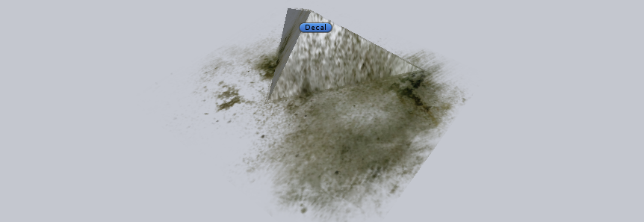

1. Introduction

It’s simply and convenient Decal System that allows:

* Use the atlas system and sprite from Unity 4.3;
* Quickly select desired material from list of used in scene materials;
* To see quickly all the sprites and select the desired;
* Quickly set the decal position.

Inspector of decal

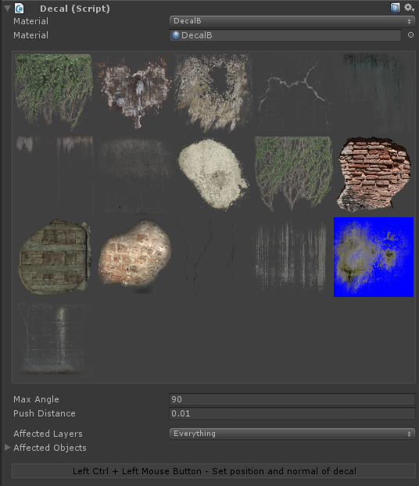

1. Getting started
   1. Select the texture of decals and at TextureType choose the Sprite.
   2. Create a new Material with transparent shader and our texture.
   3. Create a new GameObject and add Decal Component.
   4. Choose at popup menu the desired material from list of decal materials used on scene or select at object field the new material.
   5. Select from sprite list the desired sprite.
   6. In addition, you can simply set position of decal. Just You should press Left Ctrl and click Left Mouse Button on desired position. Note: you can click only on collider.